Please email to wangning@dicp.ac.cn
The template as follows:
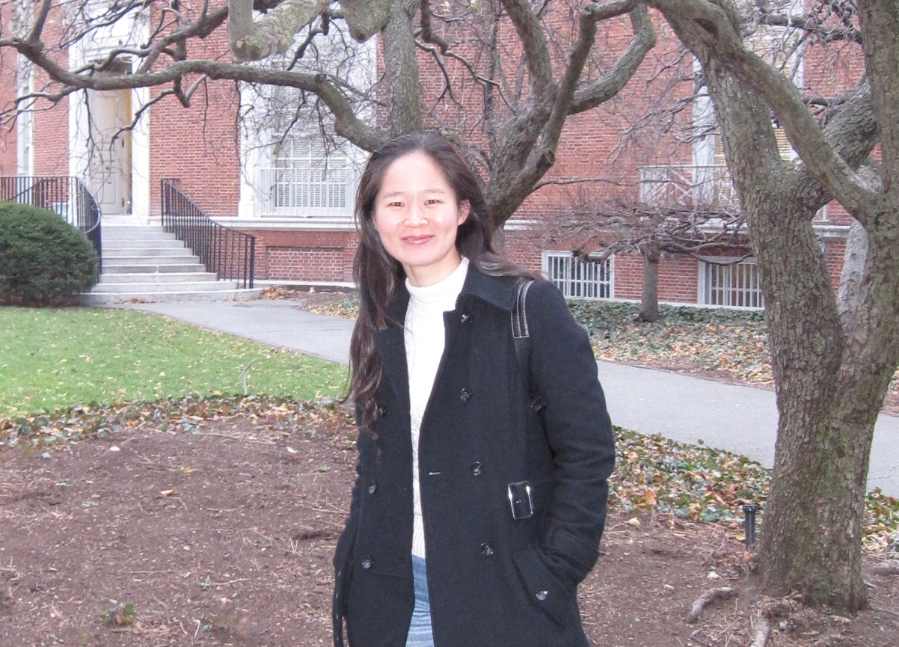
(Photo should be horizontal version, resolution ratio is 600*400)

Dr. Yan Zhou
State Key Laboratory of Catalysis
Dalian Institute of Chemical Physics
Chinese Academy of Sciences
457 Zhongshan Road, Dalian, 116023, China
Email: zhouyan@dicp.ac.cn
Tel: +86-411-84379189
Fax : +86-411-84694447
Education:
2011.12, Doctoral Degree, Xiamen University
2003.06, Bachelor Degree, China University of Geosciences (Wuhan)
Working Experience:
2015.07 – Present, Associate professor, Dalian Institute of Chemical Physics
2012.12 – 2015.06, Assistant professor, Dalian Institute of Chemical Physics
2011.12 – 2012.05, Postdoctoral, Max-Planck-Institute for Chemical Physics of
Solids (Dresden), Germany
2009.09 – 2011.11, Joint PhD, Max-Planck-Institute for Chemical Physics of Solids
(Dresden), Germany
2003.07 – 2005.08, Assistant Engineer, China Sanjiang Space Group
Research Topic:
In-situ & dynamic characterization of catalyst under working conditions with x-ray spectroscopy and electron microscopy techniques

